Enhanced lifetime, reliability and performance of electro-mechanical wing actuation systems demonstrated by ISSELUBB project

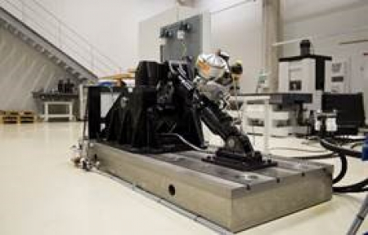

05 September 2019

Clean Sky 2’s ISSELUB project, part of the Systems technology platform, has completed a series of investigations into enhancing the lifetime, reliability and performance of electro-mechanical wing actuation systems.   
    
The overall goal of the project was focused on incrementing the efficiency of electro-mechanical and electro-hydrostatic systems in terms of extending the life, improving the reliability, and enhancing the performance of the maintenance activities of wing actuation systems. The project investigated and improved innovative sealing and sensor solutions, combined with health monitoring technologies able to monitor the actuation systems and to detect and predict failures at an early stage in order to avoid a catastrophic fault.   
    
The technologies investigated in the ISSELUB project will contribute to the reduction of fuel consumption of the aircraft, as well to a reduction in maintenance actions, therefore increasing the life of components and reducing the need to change them.   
    
Two institutions were involved in the project: Liebherr-Aerospace Lindenberg GmbH (Topic Manager) and IK-Tekniker.